**The Anatomy of CSS**

**CSS Syntax**

CSSA Syntax:

Selector{ property : value;}

Selector (Who): body, heading, hr, image (img) etc.

Property (What): Backgroung-color, border-style, border-width, color: #66BFBF, border-width, font-size etc.

Value (How): color is red, blue, black, border-style: none, border-width: 5px etc.

Case Sensitive: ends with semi-colon.

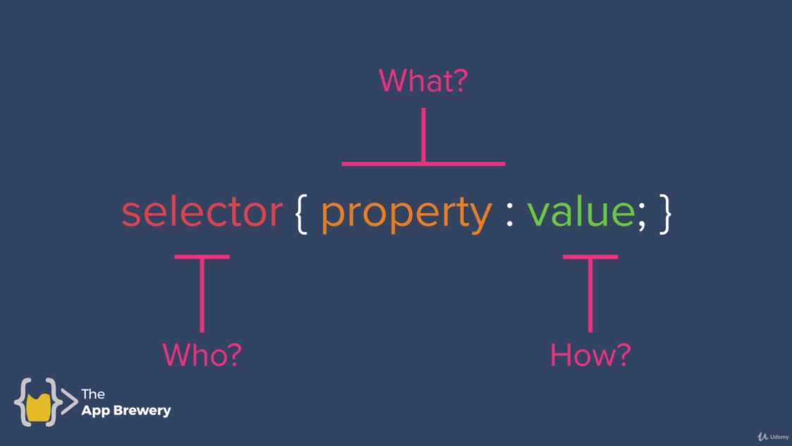

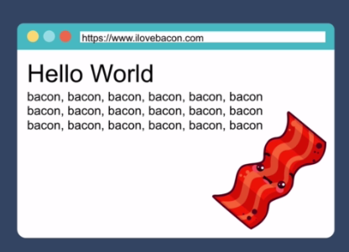

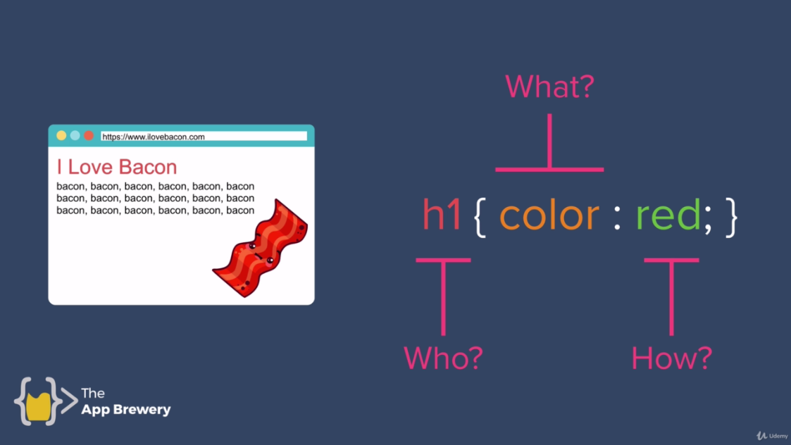

**Important link of Syntax:**

<https://developer.mozilla.org/en-US/docs/Web/CSS/Reference>

This website link is all about syntax. To learn about it scroll down and click on property you want like **background-color**

# background-color

The **background-color** [CSS](https://developer.mozilla.org/en-US/docs/Web/CSS) property sets the background color of an element.

## [Try it](https://developer.mozilla.org/en-US/docs/Web/CSS/background-color#try_it)

* background-color: brown;
* background-color: #74992e;
* background-color: rgb(255, 255, 128);
* background-color: rgba(255, 255, 128, .5);
* background-color: hsl(50, 33%, 25%);
* background-color: hsla(50, 33%, 25%, .75); etc.

## [Syntax](https://developer.mozilla.org/en-US/docs/Web/CSS/background-color#syntax)

/* Keyword values */

background-color: red;

background-color: indigo;

/* Hexadecimal value */

background-color: #bbff00; /* Fully opaque */

background-color: #bf0; /* Fully opaque shorthand */

background-color: #11ffee00; /* Fully transparent */

background-color: #1fe0; /* Fully transparent shorthand */

background-color: #11ffeeff; /* Fully opaque */

background-color: #1fef; /* Fully opaque shorthand */

/* RGB value */

background-color: rgb(255, 255, 128); /* Fully opaque */

background-color: rgba(117, 190, 218, 0.5); /* 50% transparent */

/* HSL value */

background-color: hsl(50, 33%, 25%); /* Fully opaque */

background-color: hsla(50, 33%, 25%, 0.75); /* 75% opaque, i.e. 25% transparent */

/* Special keyword values */

background-color: currentcolor;

background-color: transparent;

/* Global values */

background-color: inherit;

background-color: initial;

background-color: revert;

background-color: revert-layer;

background-color: unset;

Copy to Clipboard

The background-color property is specified as a single <color> value.

### [Values](https://developer.mozilla.org/en-US/docs/Web/CSS/background-color#values)

[<color>](https://developer.mozilla.org/en-US/docs/Web/CSS/color_value)

The uniform color of the background. It is rendered behind any [background-image](https://developer.mozilla.org/en-US/docs/Web/CSS/background-image) that is specified, although the color will still be visible through any transparency in the image.

## [Accessibility concerns](https://developer.mozilla.org/en-US/docs/Web/CSS/background-color#accessibility_concerns)

It is important to ensure that the contrast ratio between the background color and the color of the text placed over it is high enough that people experiencing low vision conditions will be able to read the content of the page.

Color contrast ratio is determined by comparing the luminance of the text and background color values. In order to meet current [Web Content Accessibility Guidelines (WCAG)](https://www.w3.org/WAI/standards-guidelines/wcag/), a ratio of 4.5:1 is required for text content and 3:1 for larger text such as headings. Large text is defined as 18.66px and [bold](https://developer.mozilla.org/en-US/docs/Web/CSS/font-weight) or larger, or 24px or larger.

***Code:***

**Style.css:**

body{

/*background-color: red; //cpmments

*/

}

h1{

color: red;

font-size: 100px;

}

img{

background-color: red;

}

**Index.html:**

<!DOCTYPE html>

<html lang="en" dir="ltr">

<head>

<meta charset="utf-8">

<title>BScon Fansite</title>

<link rel="stylesheet" href="css/styles.css">

</head>

<body>

<h1>I Love Bacon</h1>

<p>bacon, bacon, bacon, bacon, bacon, bacon</p>

<p>bacon, bacon, bacon, bacon, bacon, bacon</p>

<p>bacon, bacon, bacon, bacon, bacon, bacon</p>

<img src="D:\University\Web Notes\Web Development Codes\CSS\bacon.jpg" alt="bacon circular">

</body>

</html>